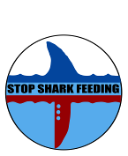

SHARK MONITORING PROGRAM
Questionnaire

Hello, we are doing a survey for the south Sinai protectorates about the shark observation. We would be grateful if you would answer the following questions and update us with any new observation. Your cooperation is an asset to provide better management and conservation to the marine life.

Name -----------------------------(Optional) Diving center (company)---------------------
Job ------------------------------------------------ Phone -----------------------------------------------
E-mail -------------------------------------------- Date--------------------------------------------------

Q1. Activity? □ Diving □ snorkeling □ Other---------

Q2. Experience in Sharm El-Shiekh? --------- years

Q3. During the last 30 days:
- how many dives have you done? ---------
- how many times have you snorkeled? ---------

Q4. Have you seen sharks in the last 30 days?
□ Yes (go to the table) □ No (site(s)-------------------------------------) (go to Q5)
□ | 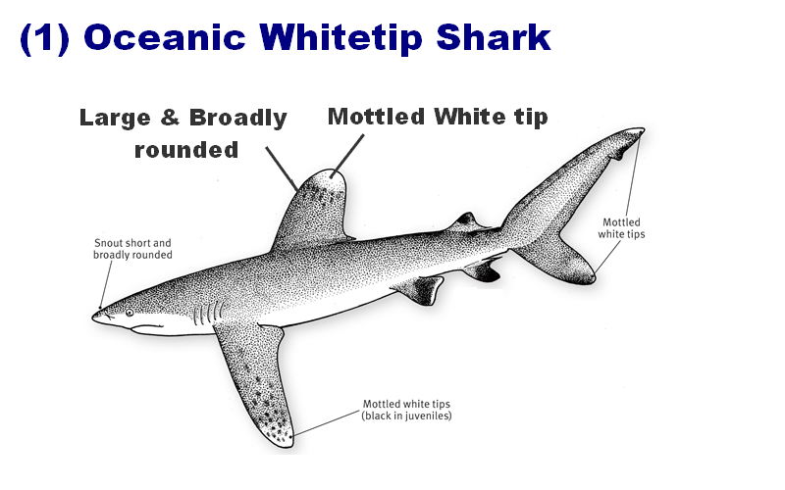 | - How many? -------------------------  - Where? ---------------------------  - Size? ----------------M  - Date / Time? ------------------/-------------AM/PM  - Depth?--------------M  - Distance from the reef?--------------------------M  - Direction (going to)? -------------------
- Behaviour and remarks?
□ Normal □ Remarks ----------------------------------------------
□ Straightaway approach to diver/swimmer □ Shark followed diver/swimmer towards shore □ Sudden interaction between shark and diver/swimmer
□ Others --------------------------------------------------------------------------------------------------------------------
□ | 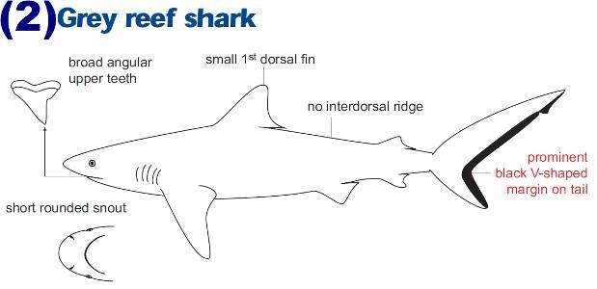 | - How many? -------------------------  - Where? ---------------------------  - Size? ----------------M  - Date / Time? ------------------/-------------AM/PM  - Depth?--------------M  - Distance from the reef?--------------------------M  - Direction (going to)? -------------------
- Behaviour and remarks?
□ Normal □ Remarks ----------------------------------------------
□ Straightaway approach to diver/swimmer □ Shark followed diver/swimmer towards shore □ Sudden interaction between shark and diver/swimmer
□ Others --------------------------------------------------------------------------------------------------------------------
□ | 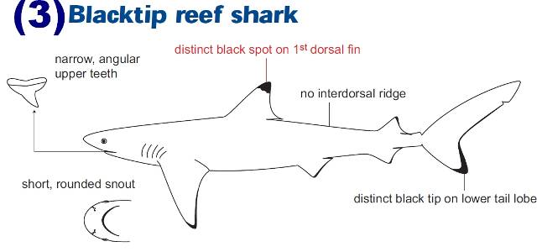 | - How many? -------------------------  - Where? ---------------------------  - Size? ----------------M  - Date / Time? ------------------/-------------AM/PM  - Depth?--------------M  - Distance from the reef?--------------------------M  - Direction (going to)? -------------------
- Behaviour and remarks?
□ Normal □ Remarks ----------------------------------------------
□ Straightaway approach to diver/swimmer □ Shark followed diver/swimmer towards shore □ Sudden interaction between shark and diver/swimmer
□ Others --------------------------------------------------------------------------------------------------------------------
□ | 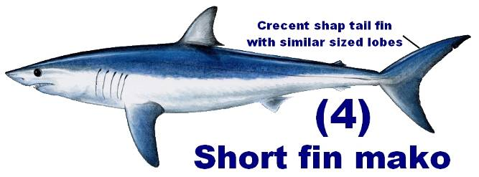 | - How many? -------------------------  - Where? ---------------------------  - Size? ----------------M  - Date / Time? ------------------/-------------AM/PM  - Depth?--------------M  - Distance from the reef?--------------------------M  - Direction (going to)? -------------------
- Behaviour and remarks?
□ Normal □ Remarks ----------------------------------------------
□ Straightaway approach to diver/swimmer □ Shark followed diver/swimmer towards shore □ Sudden interaction between shark and diver/swimmer
□ Others --------------------------------------------------------------------------------------------------------------------
□ | 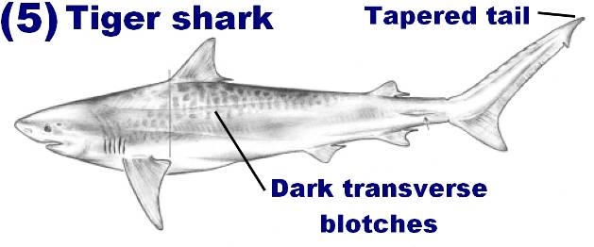 | - How many? -------------------------  - Where? ---------------------------  - Size? ----------------M  - Date / Time? ------------------/-------------AM/PM  - Depth?--------------M  - Distance from the reef?--------------------------M  - Direction (going to)? -------------------
- Behaviour and remarks?
□ Normal □ Remarks ----------------------------------------------
□ Straightaway approach to diver/swimmer □ Shark followed diver/swimmer towards shore □ Sudden interaction between shark and diver/swimmer
□ Others --------------------------------------------------------------------------------------------------------------------
□ | 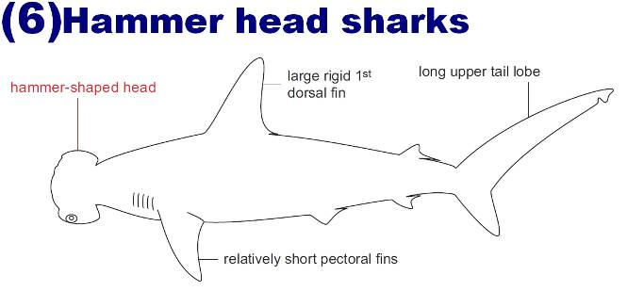 | - How many? -------------------------  - Where? ---------------------------  - Size? ----------------M  - Date / Time? ------------------/-------------AM/PM  - Depth?--------------M  - Distance from the reef?--------------------------M  - Direction (going to)? -------------------
- Behaviour and remarks?
□ Normal □ Remarks ----------------------------------------------
□ Straightaway approach to diver/swimmer □ Shark followed diver/swimmer towards shore □ Sudden interaction between shark and diver/swimmer
□ Others --------------------------------------------------------------------------------------------------------------------
□ | 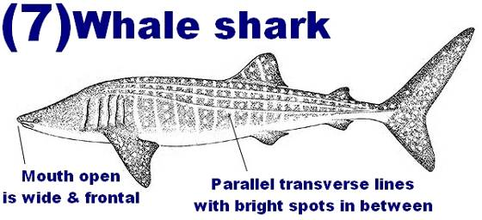 | - How many? -------------------------  - Where? ---------------------------  - Size? ----------------M  - Date / Time? ------------------/-------------AM/PM  - Depth?--------------M  - Distance from the reef?--------------------------M  - Direction (going to)? -------------------
- Behaviour and remarks?
□ Normal □ Remarks ----------------------------------------------
□ Straightaway approach to diver/swimmer □ Shark followed diver/swimmer towards shore □ Sudden interaction between shark and diver/swimmer
□ Others --------------------------------------------------------------------------------------------------------------------
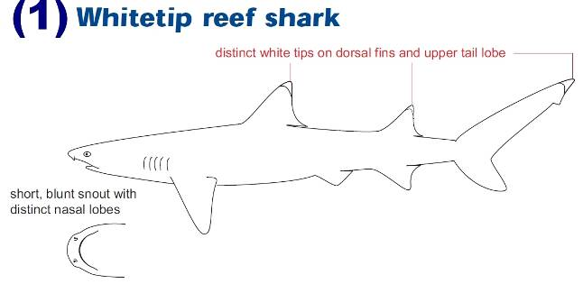  □  (8) |  | - How many? -------------------------  - Where? ---------------------------  - Size? ----------------M  - Date / Time? ------------------/-------------AM/PM  - Depth?--------------M  - Distance from the reef?--------------------------M  - Direction (going to)? -------------------
- Behaviour and remarks?
□ Normal □ Remarks ----------------------------------------------
□ Straightaway approach to diver/swimmer □ Shark followed diver/swimmer towards shore □ Sudden interaction between shark and diver/swimmer
□ Others --------------------------------------------------------------------------------------------------------------------
□ | Other ----------------------------- | - How many? -------------------------  - Where? ---------------------------  - Size? ----------------M  - Date / Time? ------------------/-------------AM/PM  - Depth?--------------M  - Distance from the reef?--------------------------M  - Direction (going to)? -------------------
- Behaviour and remarks?
□ Normal □ Remarks ----------------------------------------------
□ Straightaway approach to diver/swimmer □ Shark followed diver/swimmer towards shore □ Sudden interaction between shark and diver/swimmer
□ Others --------------------------------------------------------------------------------------------------------------------

Q5. Have you seen (or heard about) shark feeding in Sharm El-Sheikh?
□ Yes □ No
If Yes,
  - how many? -----------------------------------
  - where? ----------------------------------------

Q6. Do you have any other comments?
------------------------------------------------------------------------------------------------------------------------------------------------------------------------------------------------------------------------------------------------------------------------------------------------------------------------------------------------------------------------------------------------------
- If you have taken photos/videos for the sharks, please send them to sharksighting@yahoo.com
For any further information, please contact South Sinai Protectorates
Fax: 0693660668 -559 Tel. / Mr. Magdy Saad 0127576458 - Mr. Waleed Hassan 0101108926

Thank you very much for taking part in this survey!

